CHAPTER 1
CHAPTER TITLE(font size 16)
  - Section (font size is 14, Times New roman)
    - Sub section(font size is 14,Times New roman)
The text size should be 12 in times new roman. Figures should be centre justified with proper figure number. Equations should be numbered and should be typed using equation editor option of the Microsoft word. Finally, all the tables should be numbered and table description should be done above the table.
(Examples for image, table and equations given below)
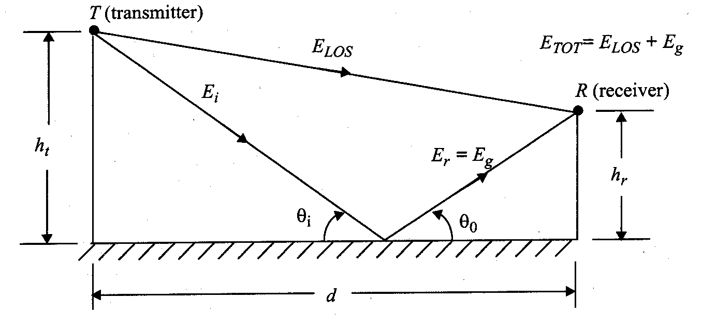
Figure 1.1: Two Ray Model

Table 1.1: Table Description
XYZ | X | Y | Z | S
1
2
3
4

S_{δ}(f )= F[s_{δ}(t)] = f_{s} 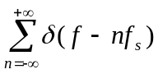 (1.1)

